Javascript Execution Context

* Global Execution Context
* Function Execution Context
* Eval Execution Context

Javascript files runs in 2 phase:

1. Memory Creation Phase (Memory is Allocated to the variables , functions, etc.)
2. Execution Phase

Example:-

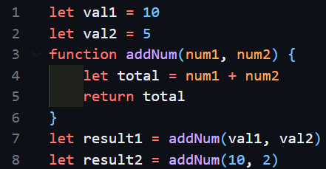

Step – 1:

Global Execution Phase -> This keyword

Step – 2:

Memory Phase:

val1 -> undefined

val2 -> undefined

addNum -> function definition

result1 -> undefined

result2 -> undefined

Step – 3:

Execution Phase:

val1 <- 10

val2 <- 5

total <- 15

addNum 🡪

New Variable Environment

+

Execution Thread

NEC

* Whenever any function executes, it creates a box called NEW EXECUTION CONTEXT (NEC).
* If NEC works is done, it is deleted.